Teacher  Shelley Rish/ 3-5 PLC |  | Date  9/11 – 9/15 |  | Grade  3-5 |  | Content Area  Science
Objective/Essential Question:  What is matter, the three phases, and how can we identify a solid?  Physical Skills: Each student will participate to the extent of their physical abilities of the lesson. They will practice not only gross motor but fine motor skills by activating switches, reaching for materials and interacting with peers and classroom staff.  - Cognitive Skills:  Symbolic: the students will identify different changes in matter and create a KWHL chart, independently interact with materials, and answer prediction and comprehension questions independently without the use of objects.  Early Symbolic: the student will identify different changes in matter, interact with science materials when provided gestural prompts, and answer prediction and comprehension questions with minimal prompting.  Pre-Symbolic: the students will demonstrate awareness of different changes in matter, with minimal prompting, interact with different temperatures with maximum assistance if needed, and answer prediction and comprehension questions with the use of objects, and point to or look at vocabulary words.  - Social Skills (learning teams): The students will have the opportunity to interact with peers not only during whole group instruction but also in small group. |  |  |  |  |  |  |  | Plan for Differentiation:  Using Bloom’s Revised Taxonomy  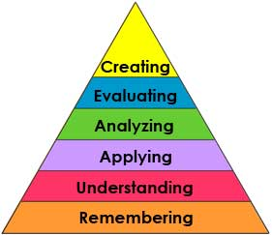
Materials
Picture Symbols, smart board lesson, different solids and different liquids to compare to each other
Vocabulary (Literacy)
Solid, matter, block, car, notebook, bus
Technology
Switches, smartboard lesson
Curriculum Standard:

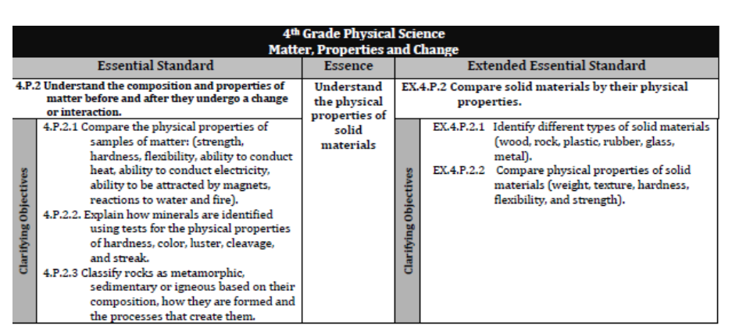

Lesson Procedures
Review (Links to Prior Knowledge, Anticipatory Set): Students are exposed to text in all academic areas. The students will be exposed to solids on a daily basis.
What the teacher will do:
- The teacher will prepare the environment so all students have their AAC devices needed to optimize their participation.
- The teacher will direct the lesson from the smartboard. Giving many opportunities for the students to participate.

What the teacher assistants will do:
The teacher assistants at the beginning of the lesson will assist the students with access to the devices. They will collect data to track responses from the students.
Guided/Independent Practice/Group Work
Guided practice: The teacher will present the lesson and utilize constant time delay to increase accuracy.
Independent practice: Each student has the opportunity to participate in the lesson by using their switches, and answering questions.
Group Work/Working teams: Students will be divided into groups either based on ability/understanding or the groups will be chosen by the students themselves.
Assessment/Check for Understanding
The teacher will use comprehension questions throughout the lesson varying the type and or the amount of choices presented to the students. She will utilize constant time delay to increase the accuracy of the responses. The students will complete activities related to the topic and will be assessed using the prompting levels.
Closure/Summary
Students will be assessed on the objectives and/or comprehension questions.
Reflection  (after teaching the lesson) | Differentiation |  | Student Engagement |  | Data  Collection |  | Higher Level Question |  | Lesson Effectiveness
 | Low High  1 2 3 4 5 |  | Low High  1 2 3 4 5 |  | Low High  1 2 3 4 5 |  | Low High  1 2 3 4 5 |  | Low High  1 2 3 4 5
Comments | What would you do differently and what worked well?

